# Program to add two matrices using nested loop

X = [[12,7,3],

[4 ,5,6],

[7 ,8,9]]

Y = [[5,8,1],

[6,7,3],

[4,5,9]]

result = [[0,0,0],

[0,0,0],

[0,0,0]]

for i in range(len(X)):

for j in range(len(X[i])):

result[i][j] = X[i][j] + Y[i][j]

for r in result:

print(r)

# 2. Program to multiply two matrices using nested loops

# 3x3 matrix

X = [[12,7,3],

[4 ,5,6],

[7 ,8,9]]

# 3x4 matrix

Y = [[5,8,1,2],

[6,7,3,0],

[4,5,9,1]]

# result is 3x4

result = [[0,0,0,0],

[0,0,0,0],

[0,0,0,0]]

# iterate through rows of X

for i in range(len(X)):

# iterate through columns of Y

for j in range(len(Y[i])):

# iterate through rows of Y

for k in range(len(Y)):

result[i][j] += X[i][k] * Y[k][j]

for r in result:

print(r)

3.

import numpy as np

# 2x2 matrix with 1's on main diagnol

a = np.identity(2, dtype=float)

print("Matrix a : \n", a)

# 3x3 matrix with 1's on main diagonal

b = np.identity(3)

print("\nMatrix b : \n", b)

# 3x3 matrix with 1's on main diagonal with string datatype

c = np.identity(3, dtype=str)

print("\nMatrix c : \n", c)

# 3x3 matrix with 1's on main diagonal with int datatype

d = np.identity(3, dtype=int)

print("\nMatrix d : \n", d)

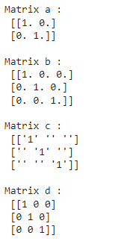

4. import numpy as np

# creating a 2X2 Numpy matrix

n_array = np.array([[50, 29], [30, 44]])

# Displaying the Matrix

print("Numpy Matrix is:")

print(n_array)

# calculating the determinant of matrix

det = np.linalg.det(n_array)

print("\nDeterminant of given 2X2 matrix:")

print(int(det))

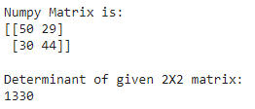

#importing and viewing

import pandas as pd;

csv_url = 'https://archive.ics.uci.edu/ml/machine-learning-databases/iris/iris.data'

col_names = ['Sepal_Length','Sepal_Width','Petal_Length','Petal_Width','Class']

iris = pd.read_csv(csv_url, names = col_names)

print(iris.head())

print(iris.tail())

print(iris.dtypes)

